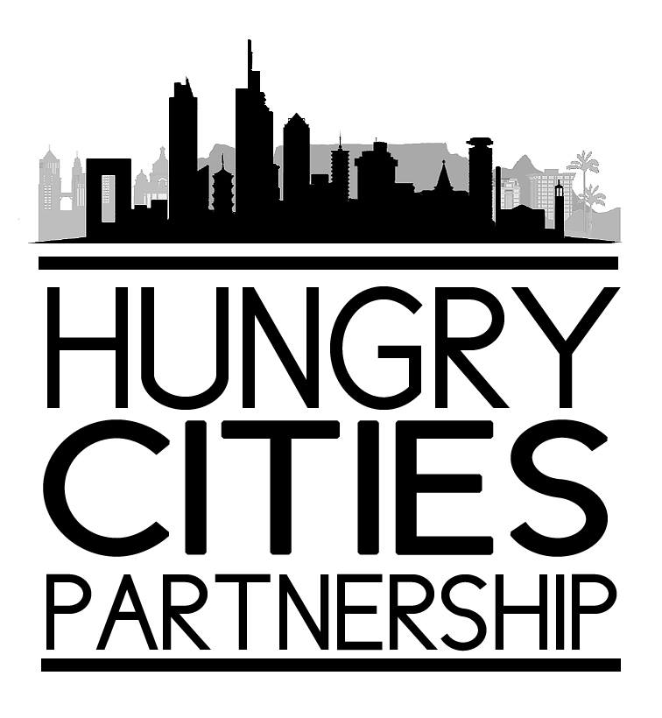

GEOGRAPHIES OF FOOD AND FOOD SECURITY
An International Conference of the
The Hungry Cities Partnership in association with the Commonwealth Geographical Bureau
Maputo, Mozambique July 7-9, 2017
FIRST CIRCULAR
Background
Foods of many types and nutritional values are produced and consumed in varied ways and different amounts across the world. The patterns of the stability of both production and consumption are affected by a wide range of bio-physical and socio-economic drivers, and these are further conditioned by political and cultural contexts. Who produces and who consumes what types and amounts of food are reflections of existing levels of assets inequity at all scales – from the global and national to the community and household. The people with least assets and, therefore, the most vulnerable in terms of regular access to adequate food, are the poor in countries of the Global South. In some cases the vulnerability of poverty is compounded by prolonged military conflict, disease epidemics, as well as the inequitable competition for agricultural land and water in rural areas, and for affordable retailed food in urban centres. The strategies employed by people to secure food further reflect variations based on gender roles, knowledge base, technological capabilities, perceptions and issues of governance. Additionally, a food transition is currently in process with traditional diets frequently being replaced by new options. The trend is towards higher consumption of calories, fats and animal products, as populations become influenced by the globalized marketing strategies of ‘big food’ which is changing food preferences, including those of the poor.

In light of the patterns of global population growth and increasing urbanization, the robustness of food systems are of paramount importance. Although sufficient food is currently produced in the world for all, an estimated billion people go hungry whilst another billion people overconsume. Both situations have significant implications for nutrition and health. The state of food security is by no means uniform and, while there has been considerable progress in some countries, in others large proportions of the population are undernourished and numbers have risen since the beginning of the present century.
A household’s food system incorporates all the food chains in which it participates to meet its consumption requirements and culturally-conditioned dietary preferences. Even in relatively simple food systems, there is a need for some items that are produced outside the local area, and these have to be purchased or otherwise obtained through social networks. Urban populations, in particular, are highly dependent on the cash economy to secure food, which makes them vulnerable to the effects of rising food prices. It appears that a blend of formal and informal livelihoods and food systems in both rural and urban contexts increases the resilience of the poor to access food with limited assets. Vulnerability and resilience are manifest in a variety of situations, and the aspects of vulnerability to which populations fall victim tend to be location- and society-specific.

Research from a number of disciplinary perspectives have explored and analyzed many of these issues which, when brought together in a single forum, should greatly enhance our understanding and enable clear policy recommendations to be made.

***************************
Conference Sessions
The conference will explore a range of themes relating to the geography of food and food security, including:
1. Food production, global and local challenges and cases of good practice
2. Food consumption, with special reference to urban challenges and solutions
3. Food, nutrition and health
4. Gender roles in food systems
5. Food in the formal and informal sectors
6. The role of migration in food production and consumption patterns and preferences
7. Food security in the context of natural disasters and in the face of armed conflict and disease pandemics
8. Food policy and governance
Prospective participants are invited to propose a panel of 4-5 presenters, or to suggest a single paper for inclusion in one of the panels. Suggested panels and abstracts of papers should be sent to the organizers no later than March 13, 2017. These should be sent to Professor Elizabeth Thomas-Hope at Email: elizabeth.thomashope@uwimona.edu.jm and copied to Dr. Gareth Hayson at gareth.haysom@uct.ac.za

Accommodation and costs
The Second Circular will provide information on local arrangements, including details of accommodation and costs.

